EXPERIMENT 2

AIM: Draw an ER diagram of Sailor database

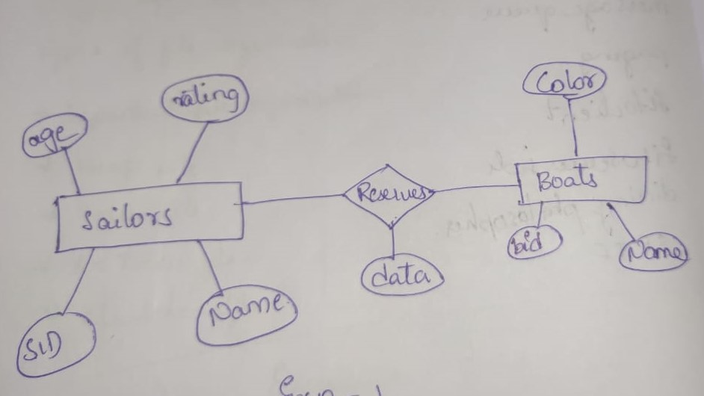

Color

Name

Bid

Boats

reserves

NAME

SID

RATING

AGE

Sailors